Battlestar Galactica : The Run
All images used were found using the Google search engine.

Game overview:
Battlestar Galactica : The Run is a strategy game on PC for Steam download. The game combines turn based crew, ship and resource management with fast paced real time combat to defend the Galactica and the fleet from brutal Cylon attack. Players must manage all fleet operations including crew assignments, assigning research tasks, planning fleet movements and interacting with the in game advisors that take the form of major characters from the series. The real time game play takes place during a battle encounter where the player takes control of the Galactica herself by ordering which targets the guns fire at, how many squadrons of limited and expendable Vipers to launch, weather to use special abilities such as limited nuclear weapons and how to deploy all of these in order to protect the whole fleet.

Major characters relevant to the games story:

Commander William Adama:
Commander of the Battlestar Galactica and veteran of two Cylon wars. He is strong willed and has excellent tactical abilities with utter command and loyalty from his entire crew. Commander Adama mistrusts politician as a general rule and has been uneasy with the un proven former school teacher Laura Roslin assuming command of the government, as such he has assumed unilateral command of all military situations with Laura accepting these terms in order to maintain a civilian government.
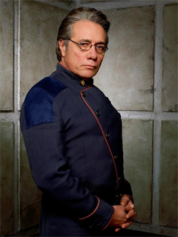
Captain Lee "Apollo" Adama:
Commander Adama's son and now Galactica's CAG(commander of the air group). Slightly rebellious of his father but an good Viper pilot and leader. Has strong romantic feelings for Starbuck but has not acted on them due to their previous history regarding Lee's brother Zak.
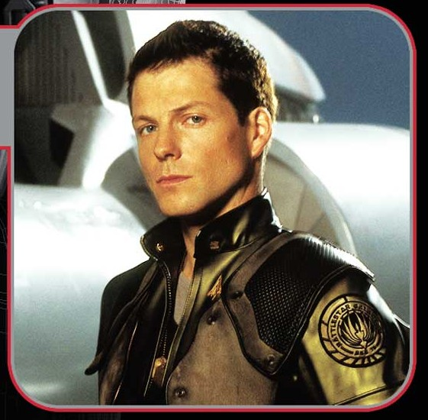
Captain Kara "Starbuck" Thrace:
Galactica's best Viper pilot and talented sniper. Kara has discipline issues and sometimes complete insubordination for the chain of command which has been overlooked by many officers due to her piloting skills. She was engaged to commander Adama's now deceased son Zak which has made her, Commander Adama and Lee very close.
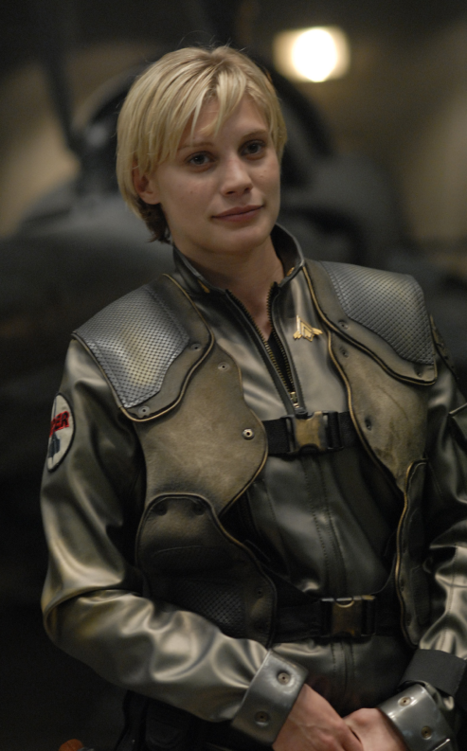
Coronel Saul Tigh:
Galactica's Executive officer(XO) and commander Adama's right hand man. He is tough and capable but has deep personality flaws due to his drinking problems. The Commander see's him as his best friend and trusts him implicitly.
Chief Galen Tyrol:
Chief Tyrol is Galactica's deck chief and is in charge of keeping all of the Viper's flying and other general maintenance operations. He and Sharon Valerii are romantically involved together and have been keeping their relationship a secret due to it being against regulations.
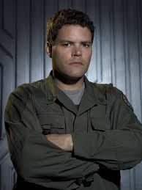
Sharon "Boomer" Valerii: Lieutenant Valerii has been a Raptor pilot on board the Galactica for two years. She is a highly capable pilot and gets along very well with her fellow crew, she has a secret romantic relationship with Chief Tyrol. Sharon Valerii is also a Cylon sleeper agent, she has no idea of her Cylon nature but has been prone to blackouts where she has sabotaged crucial operations.
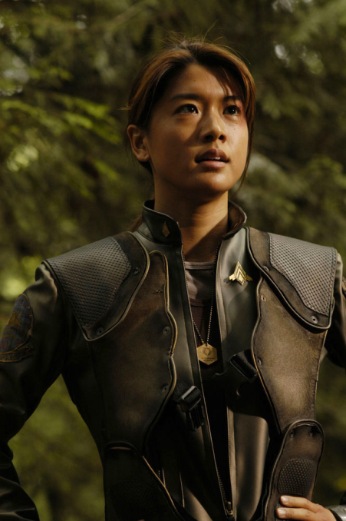

President of the colonies Laura Roslin:

President Roslin was the education minister before the fall, forty three places removed in terms of succession from the previous president Adar. She assumed the presidency after replying to the case orange communication flash after the Cylon attack. President Roslin and Commander Adama have been known to disagree on some policies but they have a good but fragile working relationship leading the fleet. She is a firm believer in the colonial belief that earth really exits and that she is the one to lead the fleet there. Laura also suffers from terminal breast cancer that is beginning to affect her health and thus work, only her, Galactica's doctor and her aide Billy know of this fact.

Billy Keikeya:
President Roslin's chief aide and right hand onboard colonial one. He helps the president in her duties as well as coordinates fleet logistics and population tallies. He and petty officer Dualla are romantically involved.
Petty officer "Dee" Anastasia Dualla:
Dee monitors all fleet communications on board Galactica. She is young and capable. Her father tried to talk her out of joining the fleet but she joined anyway because she wanted to believe in something. Romantically involved with Billy Keikeya.
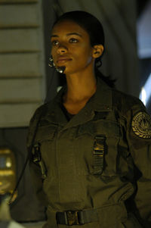
Lieutenant Felix Gaeta:
A young and capable officer who commander Adama relies heavily on as part of his senior officer compliment. Felix is Galactica's chief officer of the watch(when Cornel Tigh or Commander Adama is not on duty Felix is in command of the ship). When not in command he plots the ships FTL jumps, maintains Galactica's computer systems and assists doctor Baltar in the laboratory.
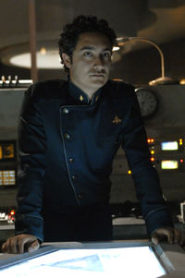
Doctor Gaius Baltar:
A brilliant and gifted scientist who heads up all Cylon research in the fleet. The doctor has recently been elected vice president of the colonies, though this was just a ploy by Laura Roslin to stop a criminal taking control of the government and the doctor has no intentions on pursuing a political career. Doctor Baltar was tricked by a Cylon agent into helping destroy the colonies and believes he still receives instructions from them via a model six only he can see. He frequently finds solace in the fact he has not been caught due to his crimes and he has little remorse for them, his chief motivator is self preservation.
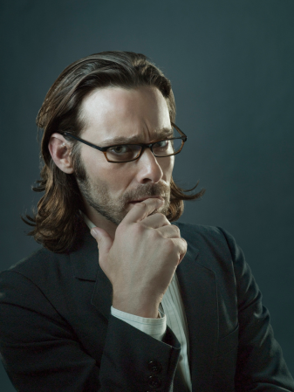
The Cylon Six Doctor Baltar see's(messenger Six):
A Cylon who appears only to Gaius Baltar and gives him information. She is deeply religious and is trying to convert the doctor to her religion and believe in 'the one true god', she refers to herself as an angel from god. It is unknown at this point in the story weather she is real or a figment of the doctors imagination. She uses the doctor to manipulate events which further the overall story and leads to confrontations with the Cylon's. The six Baltar see's looks like the regular Cylon humanoid six and frequently wears a revealing red dress.

Important locations:
Twelve colonies:
A set of twelve habitable planets in a tri-nary star system that the original twelve tribes of kobol found and settled upon to become the twelve colonies of man. The capital of the twelve colonies is Caprica which has a loose alliance with the other eleven colonies which all answer to the President of the colonies who in turn makes motions in the Quorum to govern over all of the twelve colonies and their citizens.
Kobol:
Kobol is the ancestral home world of the human race and where the thirteen tribes originally lived together before their exodus three thousand years ago. Kobol is where humans originally evolved and even though it is still a lush and animal life bearing planet it has not been home to intelligent life since the exodus.
Earth:
Earth is the fabled home where the thirteenth colony settled to call home as stated in the colonial sacred scrolls. Earth is believed to be a myth among both colonial society and the Cylon's.
Blue super giant:
An evolved high mass star that is more luminous and hotter than most others. The star in the games story gives of large amounts of radiation that interferes with colonial Dradas systems, indicating the star is near the end of its life.
Rocky planet colonial ship is found upon:
A failed planetary system situated around a brown dwarf star(a brown dwarf is a star that never reached nuclear fusion stage). There are many smaller rocky moons and planets around the brown dwarf with the ship being found upon the largest one with gravity akin to 1.3 times normal earth gravity. The colonials will still have to use space suits as the planet has no atmosphere.
System Galactica pursues rebel Basestar to:
A system containing an asteroid belt and several planets including one gas giant that has the moon the Galactica will hide behind to wait in ambush for the enemy Basestar. Centred around a red giant star.

Important terms:
Battlestar:
Essentially an aircraft carrier in space with immense amounts of firepower including the ability to launch nuclear weapons. Each Battlestar carries several squadrons of nimble single person fighters called Vipers which are the main offensive and defensive tools available to them. They are very large and can carries 1500 crew members but has the capacity to house up to 12,000 people.
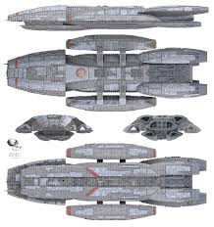Jupiter class Battlestar
Viper:
A single seat fighter craft that can operate in space and in planetary atmospheres. They are armed with two machine guns as standard and can carry both conventional and nuclear missiles.
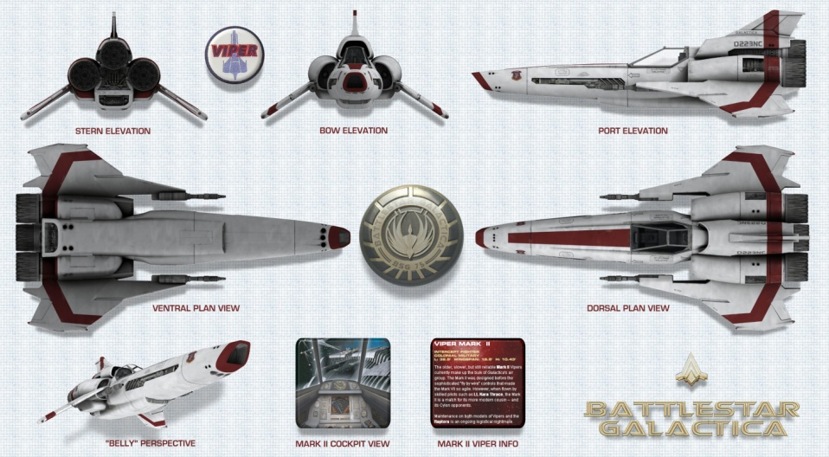
Raptor:
A multipurpose space craft mainly used for mission critical electronic countermeasures and intelligence gathering. Most Raptors are un armed but have many anti warfare systems such as communication jamming and anti missile flairs. They are the work horse of the fleet providing scouting and transport duties.
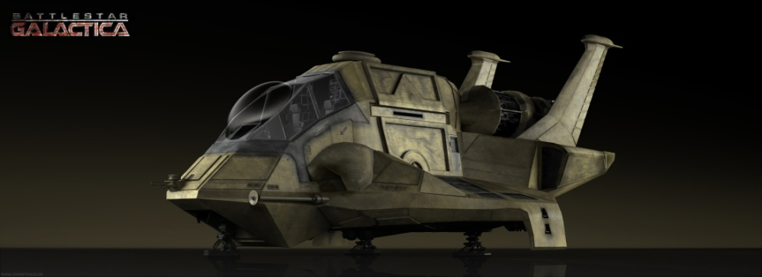
Galactica:
One of the original twelve Battlestar's which fought in the first Cylon war and was due to be decommissioned when the Cylon's came back and nuked the colonies. The Galactica is fifty years old and has many general maintenance problems but due to this fact she has survived numerous encounters with the Cylon's who cannot infiltrate her aging computer systems.
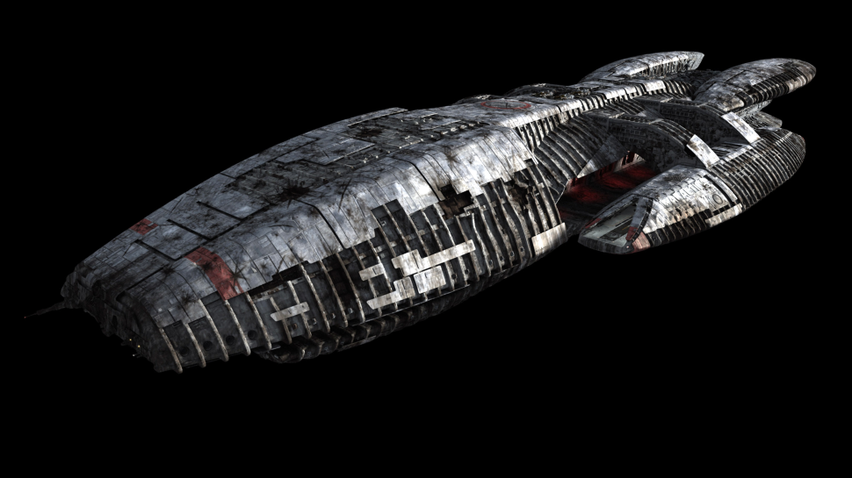
Colonial one:
The renamed ship that the now President of the colonies Laura Roslin escaped the Fall from and now houses her leading government in the fleet.
The Fall:
What the citizens of the colonies call the return of the Cylon's, when they nuked every colony and the remaining fifty thousand refugees had to run to try and find themselves a new home.
Dradas:
The colonial version of radar detection. All colonial ships use the Dradas system to map the fleets position as well as detect incoming enemy attacks. The Cylon's use a similar system.
CIC:
Combat information centre the bridge of the Galactica where all command decisions are made and relayed by Commander Adama and Coronel Tigh.
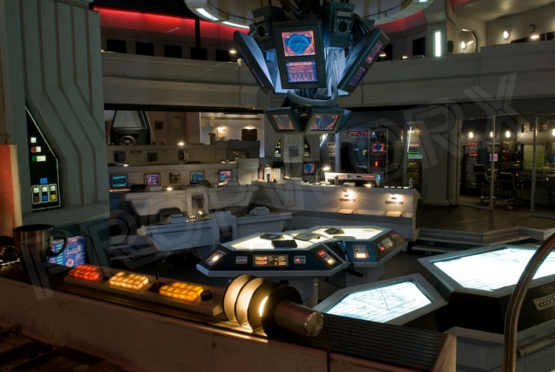
Colonial sacred scrolls:
The sacred scrolls form are a set of writings that form the basis of the colonial religion, a faith that closely resembles that of ancient Greece. The scrolls record much of the colonial alleged history including life on Kobol before the exodus, the legend of earth and the thirteen tribes journey to their respective homes. Portions of the scrolls are used in services such as marriages and funerals. The first words in the scrolls are this has all happened before and it will happen again, a recurring plot device used in the show.
Cylon(Skin job):
When the Cylon's came back to destroy the twelve colonies they were not just centurion metal robots like they were when the first Cylon war ended, they had evolved into an organic Cylon almost perfectly mimicking a human body. There are twelve different humanoid models only three of which are known of at the end of the first series. The humanoid Cylon's cannot die, when the human body is killed their knowledge and memories are downloaded into a completely new body. These Cylon's are the leaders of the Cylon race with the Raiders and centurions doing as they command.
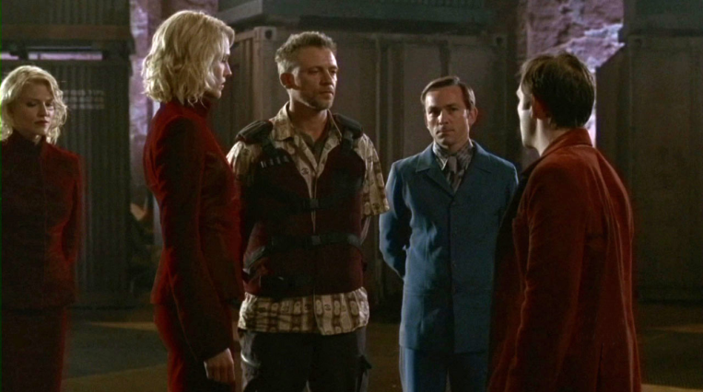
Raider/Heavy raider:
A semi organic fighter aircraft that has similar abilities to the colonial viper but with superior manoeuvrability.
The raider also has a heavy raider version which would be the Cylon version of a Raptor but used specifically for heavy fire support during space engagements and troop transport.
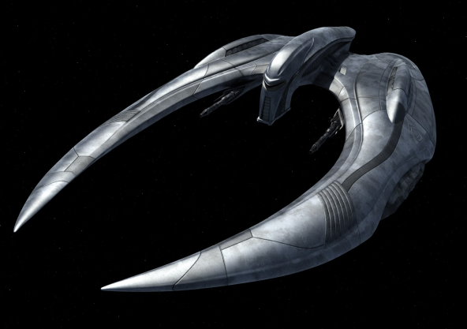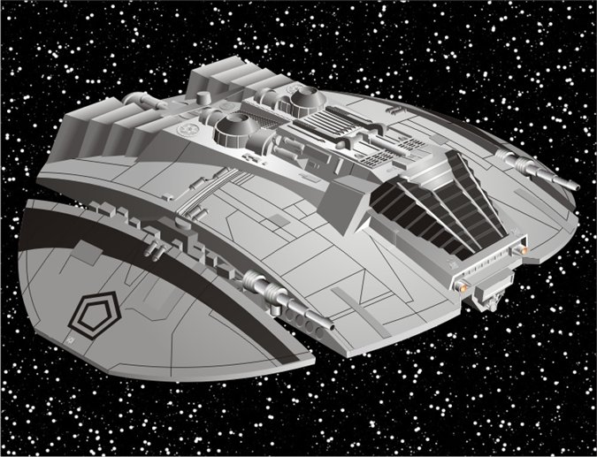
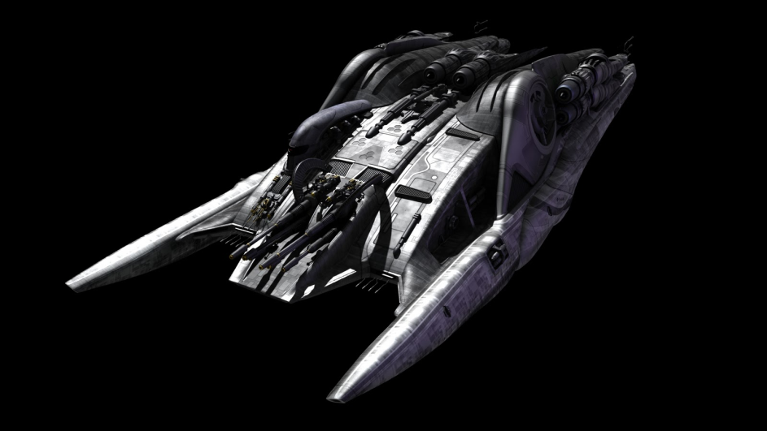
Top left-Newer Cylon Raider
Top right-Cylon raider from the first Cylon war
Bottom-Heavy Raider
Basestar:
Cylon version of a colonial Battlestar with similar abilities. Houses hundreds of Raiders and thousands of humanoid and centurion Cylon's. The Cylon Basestar is semi organic like most Cylon technology and can rebuild/regenerate damaged parts of itself over time. The Basestar also has a much longer jump range than the colonial ships.
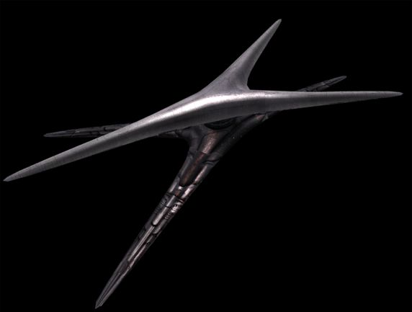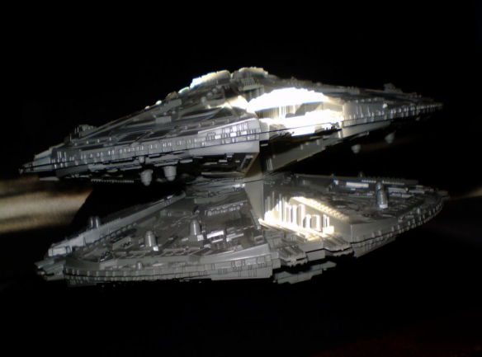
Left-Newer style Basestar
Right-Basestar from the first Cylon war
The fleet:
The fleet is a convoy of around sixty ships that house the remnants of the human race(around fifty thousand people). The fleet fled the twelve colonies after the Cylon's destroyed their homes and now search for the home of the thirteenth tribe, Earth. The fleets only protection is the aging Battlestar Galactica and her fleet of Vipers.
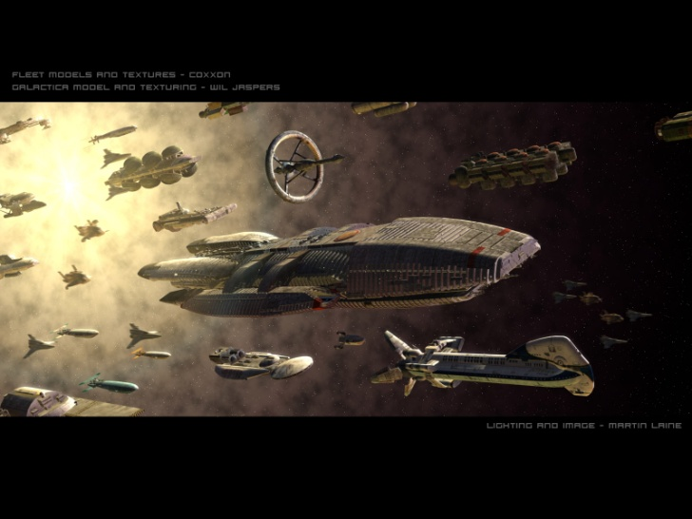
Cylon Centurion:
The centurions are the work horses of the Cylon race serving primarily as soldiers under the command of the humanoid Cylon's. They are seven ft tall all silver bipedal robots, they have the ability for free will but have been prevented from using their higher level functions due to the humanoid Cylon's fear of them rebelling against them the same way they did against the colonials. The centurions are able to use most tools and weapons using their razor blade hands and fingers as well as having a triple barrelled Gatling gun built into each arm.
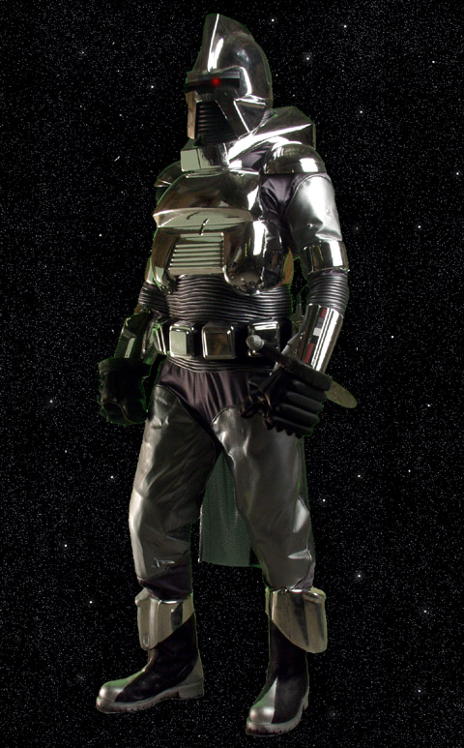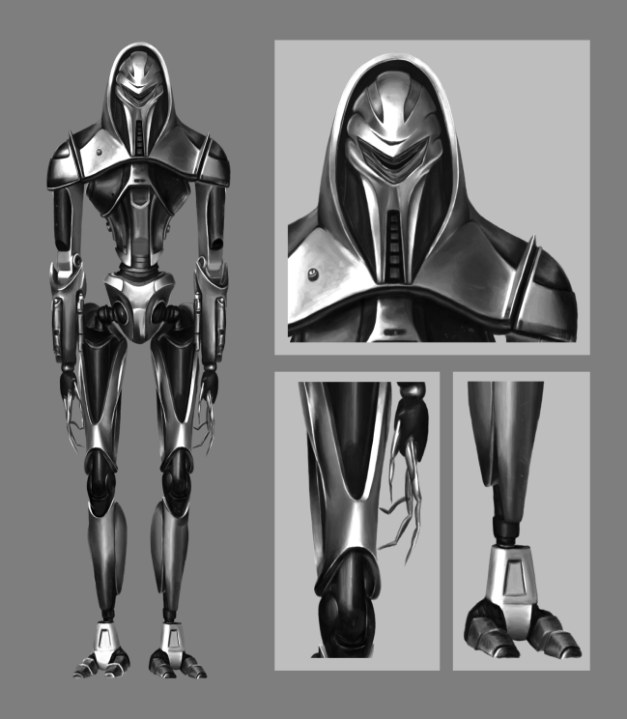
Left-Cylon centurion from the first Cylon war.
Right-New updated Cylon centurion utilised by the human form Cylon's.
FTL(faster than light) jump:
The colonials and the Cylon's use a faster than light technology to travel great distances almost instantaneously. The general jump range is dependent on the technology available. According to the science of Battlestar Galactica book an FTL jump is the folding of space time over a ship with the ship travelling through the fold to the destination input. The general jump range of colonial technology is around five light-years per jump with the Cylon's being able to jump five times that range(source-Battlestar Galactica season five).

Story Flow:
Overview:
Battlestar Galactica: The run will follow an entirely new story arc that fits in towards the end first season of the series. The Galactica will find an abandoned vessel in space that is meant to be one of the original ships that carried the twelve tribe's form Kobol thousands of years before. The Galactica will attempt to track the where about's of the ships escape pods that will lead them to multiple star systems and having to engage a rouge Cylon Basestar that is attempting to find them first. While searching for the pods one of the stories main characters will be abducted by the rouge Cylon faction and the Galactica will have to mount an assault against the Cylon's base ship in order to rescue them. The Galactica will rescue the captured crew member and destroy the rogue Basestar in the system where they find the last escape pod. The escape pod will contain an ancient body from the original colony ships along with a damaged data device that will point the fleet in the general direction of Kobol. This would form a two part episode in the series.

Act 1

The story starts with Galactica and the fleet commencing a mining operation in an asteroid field. Two days into their operation they encounter an ancient beacon from one of the thirteen tribes original colony ships deep within one of the larger asteroids. After being brought aboard for study and taken to doctor Baltar in his laboratory. A day later a single older style Cylon Basestar jumps into the asteroid system and launches a massive attack against the fleet disabling but not destroying several ships in the civilian fleet forcing the Galactica to stay and fight.
During the battle the Basestar sends over a contingent of Cylon centurions over to Galactica to retrieve the beacon, in the course of the attack the Cylon's capture doctor Baltar while he is in his lab and deck chief Tyrol as he tries to stop the centurions taking the doctor and the beacon. The Cylon's escape Galactica with all her Vipers too far away to intercept the ship they escape upon and returns to the Basestar which jumps away leaving a dozen Raiders behind to carry on the attack.
Commander Adama orders lieutenant Gator to find out how the Cylon's found them as the Galactica commences repairs. Felix comes back to the Commander sometime later informing him that the beacon had been inadvertently activated and had been sending out a signal that was tracked back to the Galactica and that same signal can still be tracked to a few systems within jump range but he will need a few days. The commander asks his senior staff to form a plan to attack the Basestar and retrieve the beacon and the hostages when their location has been determined.

Act 2

During the planning stages of the attack and while Galactica sends recon missions to possible systems where the Basestar could have gone. As usual the modern Cylon's carry on attacking the fleet during this time forcing Galactica to jump away after a short engagement each time.
Starbuck and Apollo come up with a plan to hide the Galactica behind a moon in the system that Felix had tracked the Basestar to. While Galactica hides two Raptors will approach the Basestar on minimum power to avoid detection, board the ship and retrieve the hostages and beacon.
The plan works until the Raptors try to escape when a modern Basestar jumps in and begins to attack the older style Basestar that attacked Galactica. Galactica and her Vipers move in to cover the Raptors escape and retrieve them before jumping away. Back at the fleet doctor Baltar informs Commander Adama and president Roslin that the Cylon Basestar that attacked them were part of a splinter group who didn't want to serve the human style Cylon's and tried to escape and have been looking for a home to call their own to live out in peace, they believe that the home of humanity is their future and have been searching for Kobol for fifty years.
The President and Commander Adama decide that leaving the Basestar intact for them to potentially become a new Cylon empire in a few decades would be a huge mistake and decide not to make the same mistake humanity made by not wiping out the Cylon's fifty years ago. Doctor Baltar(with a helping hand from his messenger six) and Felix Gator use the beacon to extrapolate two possible planetary systems that the ship the beacon belonged to could have crashed upon.

Act 3

The first system Galactica search's contains a blue super giant star giving off huge amounts of radiation that blocks all Dradas readings leaving the ship relying on pilots eyes to search for the ship and protect against enemy attacks. A scout force of Vipers see a few derelict Raiders, older and newer floating in space. As the Galactica moves deeper into the system a modern Basestar jumps in and launches three nuclear warheads at Galactica, two are shot down in transit but the third explodes several hundred metres from the ship still causing a large amount of damage. Galactica launches her entire compliment of Vipers and armed Raptors while the FTL drive is repaired. The Basestar is destroyed and the Galactica returns to the fleet to rearm and repair after the ambush.
Messenger six tells Gaius that the rebel Cylon fleet is close to getting the information they need, doctor Baltar as vice president of the colonies uses the quorum of twelve(under six's instructions) to order Commander Adama to carry on the fight to stop the rebels getting the information about Kobol whatever the cost. The Commander orders Chief Tyrol and his deck crew to outfit all remaining Raptors with weapons and nukes. Starbuck and Apollo lead a Raptor assault on the second system.
The Raptor assault force arrives in the system just as the rebel Basestar sends out a Raiders force to scout the planet for the crashed ships location, the Raiders turn to engage the Raptors. After a lengthy battle, losing half of their own Raptor force and having used several nukes to destroy the rebel Basestar the battle is over and a Raptor is sent back to Galactica to report the mission complete.

Epilogue

The fleet jumps in to begin searching for the crashed ship and find it after a few days. They begin to bring up remnants of the ship and try to download what they can from the damaged computer memory. A day into the salvage operation the Cylon's find them once again, Galactica and her Vipers fend off the attack long enough to bring up the people from the surface of the planet. Just before they jump away the commander orders a missile strike destroying the downed colony ship preventing the Cylon's recovering the same information from its computer banks.
The Galactica crew stand on the flight deck to salute the body of one of their ancestors they found in the ship and return his body to space in true colonial style with words spoke aloud from the scared scrolls. Messenger six comes to Baltar and says "This has all happened before and it will all happen again destroying the ship was all for nothing, Cylon and colonial will stand on Kobol once again and die together as they did thousands of years ago".

