..Top secret..

...Eyes only...

Hack or Die

Age Range
12-16

Genre
Educational hacking game

Platform
Online browser game

Overview :
Hack or Die is an online hacking game where the player is tasked with hacking into covert data from either MI5, the NSA or FSB. The player logs into their account where they create a character who is either a British, Russian or American intelligence officer. The player must use the skills they are taught as the game progresses to collect data from covert enemy intelligence servers while covering their tracks so that enemy intelligence officers cannot trace their network intrusion. The game also teaches players the basics of JavaScript coding in a fun engaging environment.

Gameplay description :
The game is set up as a website where the player will create an account and their character then they are given a set of tasks to learn the hacking techniques of the game. As the game progresses the player is taught the basics of JavaScript that are used as the games "hacking mechanics", each section of the game introduces a new concept that will teach the player JavaScript essentials such as variables, strings and loops, essential syntax and more, obviously the game does not teach players to hack real systems in the real world the game just gives the players an appropriate context to use these skills in the game.
Each section of the game begins with a short story introduction given in the form of a stylised comic book strip with the players character getting caught up in a covert operation to steal nuclear launch codes from a head of state's personnel communications.
Each time the player finds a different piece of information that comes in the form of hacked emails, audio files, code keys etc, they must send it to an appropriate source either an independent journalist to release to the public, an enemy intelligence source or an intelligence operative from your countries government. Who the player sends each bit of information to will add up and determine one of the three endings that the player is awarded(a new cold war, world war three or the conspiracy being exposed to the public).
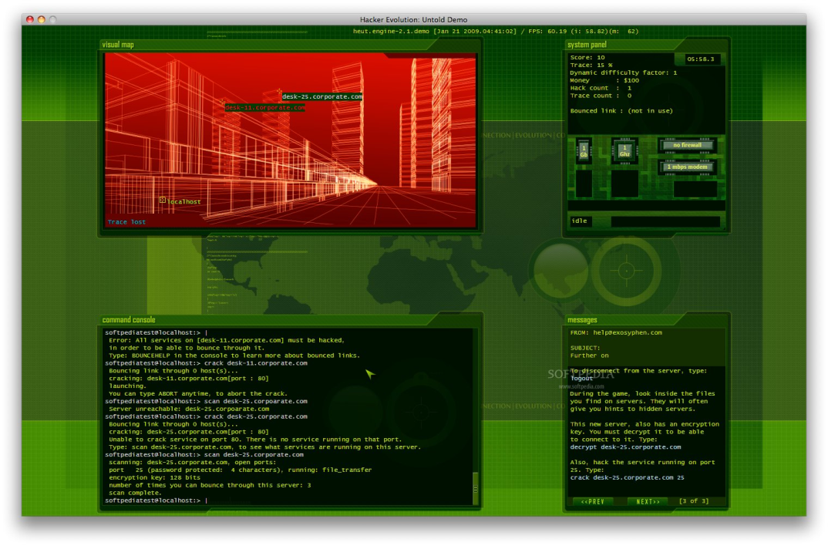
Image from the game Hacker evolution. Hack or die will use a similar screen layout.

Key Features:
- Teaches JavaScript in a fun and innovative environment
- Realistic storyline loosely based on current world events
- Deep engaging gameplay
- multiple story branches for the player to explore adding a replayability to the game
- Browser based game making it available to a wide range of devices.

Brief story outline:
Its 2016 and the global phone hacking scandal has largely been forgotten by the tabloid newspapers but it is still fresh in the minds of the most powerful people in the world, the people who have the power to launch nuclear Armageddon at the push of a button. These heads of states and ministers have commissioned there intelligence services to find out the most sensitive of information from both enemy and allied heads of state.
The player takes control of an data analyst in one of three intelligence services. The players character receives an email by accident that contains top secret information that if discovered by the public could bring down the government or worse an enemy nation could start world war three, with the information the character decides to dig deeper hoping the context of the email has been lost and there has been a huge mistake. Each successful hack adds more information to a global conspiracy of weapons developers hoping to start a new cold war in order for them to make billions on the international market.
Players must use their skills to release the right information to the right people by sending memos, emails, phone recordings to either the press or other intelligence services. The right document in the wrong hands can start a new world war but in the right hands can stop these mad men before it's too late.

Player motivation:
The players primary motivation in Hack or Die is to advance the story through the hacking gameplay while learning the basics off JavaScript.

Design Goals:
- Create a fun game that teaches the basics of JavaScript
- To tell a deep and engaging story with multiple endings
- Allow the player to choose the story outcome through the games choices

