Bookweaver(working title)

Made by Merkury Games

Genre
2D top down Role-playing game

2nd Genre
Adventure

Platforms
PC via steam Greenlight

Release date
TBA
Recommended Age
12+

Foreword
As an indie development team we can be limited by our tools, funding, size and time constraints but on the flip side we also have the opportunity to develop games we are passionate about with the freedom to create them how we want to. With these things in mind I have tried to put on paper an ambitious project that can be created by our team.

Description
Bookweaver is a top down adventure role-playing game in the style of the old Zelda and Final Fantasy games. At the start of the game the player chooses their gender and name while they go about their daily life(this serves as the games movement tutorial), once they have crossed into the book world less than five minutes in they choose what race they want to play as while they reside in the book world.
Once they have chosen their race they are thrust straight into battle with a mysterious enemy(combat tutorial) and save a village from attack.
As the game progresses the player levels up and can learn new skills in two different skill trees(magic and melee) as well as complete optional quests for money to buy new weapons and armour.
Most of the game is freely open to exploration with random and scripted battles, multiple quests to complete and treasure to find. Each section of the game has multiple areas to explore each with different enemies and environments. Each area also has a safe haven where the player can rest to recover health and magic, a shop to buy supplies, weapons and armour. This is also the main area where the player gets quests and advances the games story so they can move on in the game.

Key features
- Familiar battle system based on the final fantasy series of games
- open world design allowing the player free roam in the world
- character customisation through two skill trees and new weapons and armour selections as the player levels up
- 2D 16 bit pixel art style
- Random battles against multiple enemy types
- choose between magic and melee attacks. specialise in one or level up in both to combine combat styles
- Able to build a team to help battle through the game as some sympathetic npcs will join you in your quest

Brief story description
During a regular free lesson a teenager visits the campus library to work on their school project and stumbles into the confiscated book repository, curious why the school even has confiscated books they go in to explore and finds a thick leather bound book covered in cobwebs on a pedestal. Curiosity takes over and after turning to the first page he is surrounded by a strange light and gets sucked into the book itself. After waking up they find themselves in the middle of a burning village with three knights in distinctive black armour coming towards him when a tall warrior in a white cloak and long staff comes to his aid and fights beside him to defeat the knights.
After the battle the main character asks the warrior where he is and what's happening. During the conversation the character notices that many of the details the warrior describes was written on the first page of the book he was sucked into, the warrior tells him that certain books are a doorway to another world and he is a rare breed of person called a Bookweaver who can enter each one at will but to leave must work his way through to the end and finish the story. When asking how the story ends the warrior tells the character that the story has been changed since years ago another with the same ability came to the world and began to take the villagers and turn them into his own army, that's what the black knights were he said old friends of his turned against him by evil magic. After a much needed night's sleep the main character wakes up determined to get home and sets out to confront the other Bookweaver and get some answers.

Open world environment
The player has free roam throughout most of the game areas. Each area has several sections to explore, loot and fight enemies in. In each area there will also be at least one safe section where the player can save their game, use the shop and rest to recover health and magic. This will also be where they find most friendly npcs to interact with and get side quests.

Character Creation
When the game begins the player chooses their sex, and plays the short intro in the school's library as a generic character. when they enter the book world they choose their main character from one of three races human, elf and orc each with different starting skills( elf has the first magic skill free, human has better starting weapon/armour and the orc has the first melee skill free).

Controls
game play controls need to be as simple as possible so the player can focus on the game itself not wrestling with the controls, with that in mind the only controls used will be the Directional buttons for player movement and menu navigation, Enter to interact with npcs and the game world and M to open the character menu ingame.

Player Progression
After each battle the player earns experience points based on the difficulty of the enemies faced. Player progression works in two ways, first being a general level system with the player gaining a level when enough experience points are earned, this gives the player more health and magic points for later battles. the second is based on two skill trees specialising in magic spells and heavy melee attacks. When the player reaches a certain level they unlock the related skills appropriate to that level and can spend their accumulated experience points on unlocking the skills to use in battle.
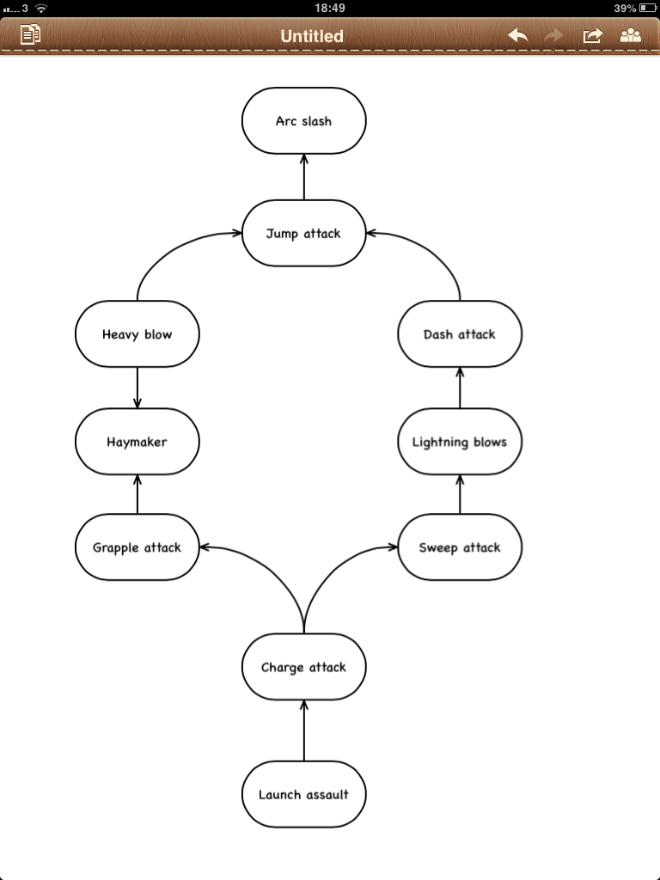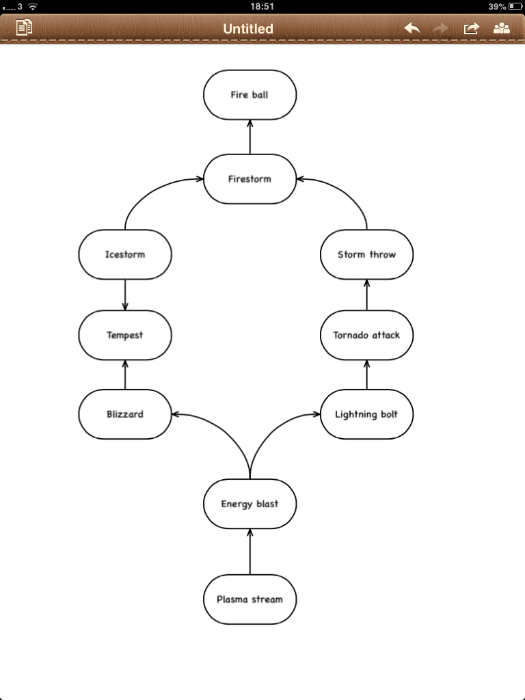

A basic first draft of the two skill trees.
Basic description of 20-30 minutes of gameplay

very basic nuts and bolts of what the player is doing in game

Design goals
- Create and open world and non linear pole playing game. In other words the player is not bound solely to the main quest and can go and explore the world to craft their own experience.
- An engaging and tactical battle system. Players should feel like winning a battle is an achievement and not just sheer luck. battles should also not become repetitive over the course of the game with new enemies that challenge the player and use different tactics. Battles should not be a case of attack, attack, attack win. We want to add strategy to the mix with enemy weaknesses and tactics for the player to adapt to and exploit.
- An engaging narrative. The main character is at heart someone thrust into a strange and difficult position, they are not a fantasy hero they are just someone who is doing what's needed to get home. The overall arc is a normal person trapped with no choice but to fight evil.

After word
The design process is a collaborative effort which cannot be under stated at any point during production especially in the preproduction stage and for the whole team to get behind the project everyone should contribute and pass judgement, say what can be improved or changed or even removed completely. Once we are all clear on what the team can/cannot achieve in terms of scope and what we want to go into the game ill start on a full design doc and story.

